Pokhara University

Level: Bachelor | Semester – Spring | Year : 2007
Programme: BE |  | Full Marks: 100
Course: Simulation and Modeling |  | Time : 3hrs.

Candidates are required to give their answers in their own words as far as practicable.
The figures in the margin indicate full marks.

Attempt all the questions.

 | - Explain the term System and its Environment. Describe all its components with examples.  - Explain three general types of statements that use CSMP III with example. | 7  8
 | - Explain various time advance mechanism using an example for each.  - Discuss in brief about events in the simulation of delayed – call telephone system. | 8  7
 | - Describe the measuring utilization ad occupancy with mathematical modeling.  - Why is an elimination of initial bias needed in simulation output? Explain with mathematical model. | 7  8
 | - Explain the advantages of Replication of Runs during analysis of simulation output.  - Workers come to a supply store at the rate of one every 5±2 minutes. Their requisitions are processed by one of two clerks who take 8±4 minutes for each requisition. The requisitions are then passed to a single storekeeper who fills them one at a time taking 4±3 minutes for each request. Write GPSS block diagram and code to simulate above program for 1000 requisitions to be filled. | 7  8
 | - Draw a simple GPSS block diagram and write program for "simulation of supermarket".  - Explain simulation language with its type. What are the desirable features of simulation software? | 7  8
 | - Solve 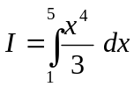by Monte Carlo method.  - Explain the various components of analog computer used in simulation. Would you like to use analog computer to simulate all kinds of systems? Give reasons. Draw the analog computer diagram to simulate a system whose behaviour is expressed by the following equations:  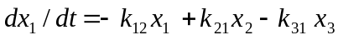  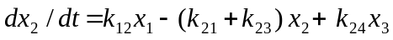  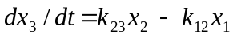 | 7  8
 | Write short notes on (Any Two):  - Bootstrapping  - Importance of differential equations in continuous system simulation  - Hybrid simulation | 2×5

